**Please watch the video (Installing Linux using Oracle VirtualBox) that was suggested by your instructor earlier.**

Install Ubuntu on your labtop using VirtualBox Software. Please use your last name as the name of your newly installed server.

Recommended websites:

<https://linus.nci.nih.gov/bdge/installUbuntu.html>

<https://www.simplehelp.net/2015/06/09/how-to-install-ubuntu-on-your-mac/>

(Note: The latest Ubuntu may have a newer version. The steps to do some tasks may be slightly altered. If you are unable to install Linux after following the correct steps, chances are that your laptop Virtualization setup needs to be enabled. Please visit the following website listed below:

<https://www.makeuseof.com/tag/virtualization-issues-simple-solutions/>)

After you have installed the Linux server, answers all questions below and submit your answers to the class blackboard. (100 points)

**Question 1**

Start your VirtualBox software. Before you click Start on your Ubuntu Graphical User Interface (GUI) desktop, at the very top of your VirtualBox bar, click “Machine”, and then click “Show Log” and a file will be displayed. Scroll up to the top of the file. You will see your desktop installation information and your desktop server name. Get a screen-shot of this file and paste it in this question as proof of your system installation.

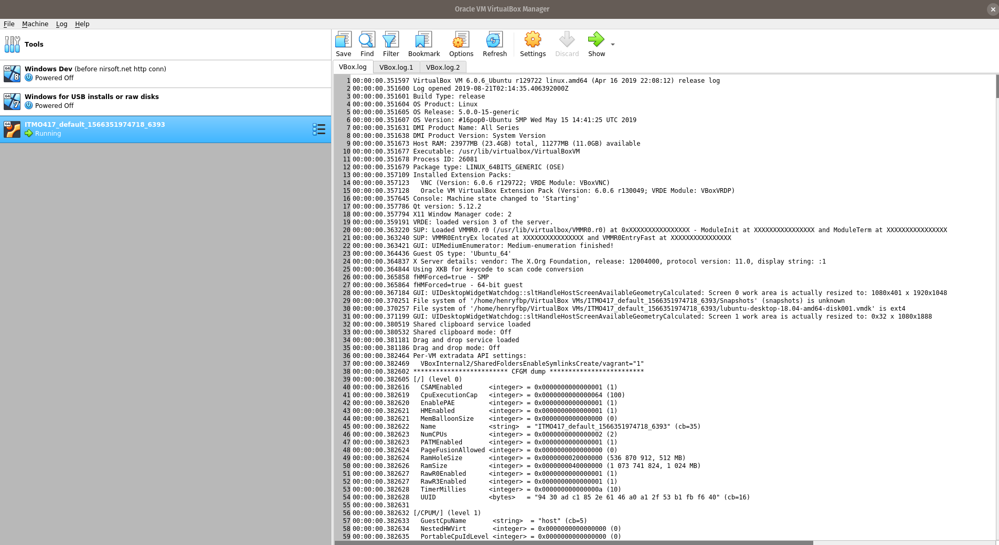

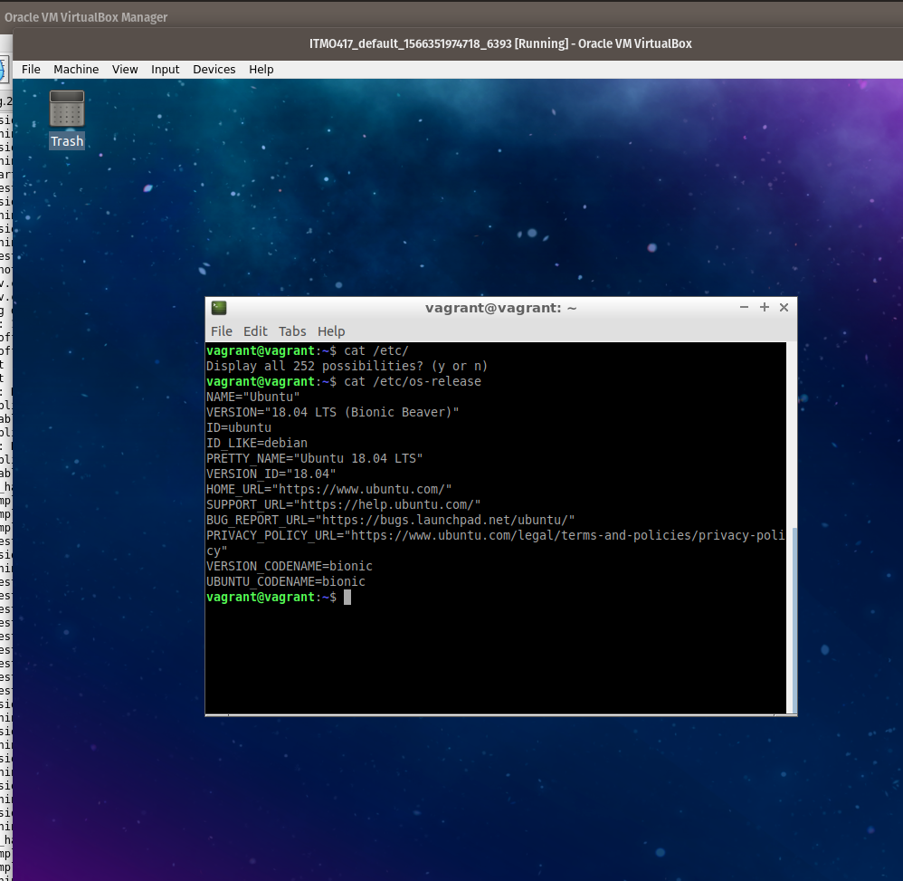

**Question 2**

Explain how you would get/display an Overview information on your Ubuntu desktop information hardware. Copy and paste the information in your answering document as proof of your work.

1. On the task bar in VirtualBox, select `Machine > Settings`.
2. Click on `System` for Motherboard, Processor, and GPU Acceleration features.
3. Click on `Storage` for storage options such as mounting VHDs or ISO files.

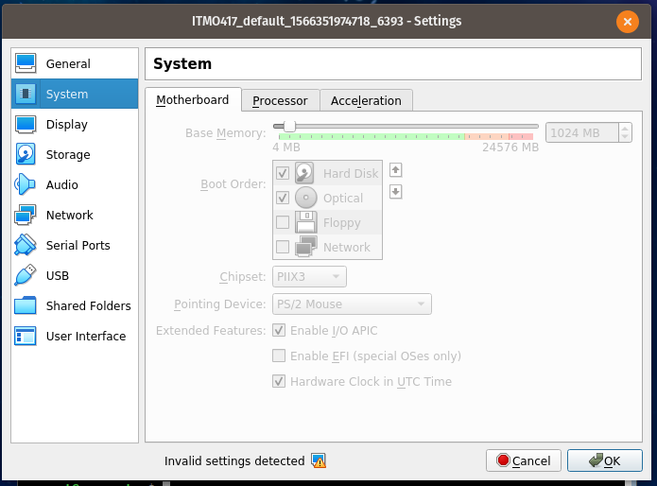

**Question 3**

Explain how you would get/display information on your Ubuntu desktop Network Wired information. Copy and paste the information in your answering document as proof of your work.

1. On the task bar in VirtualBox, select `Machine > Settings`.
2. Click on `Network` for network hardware options.

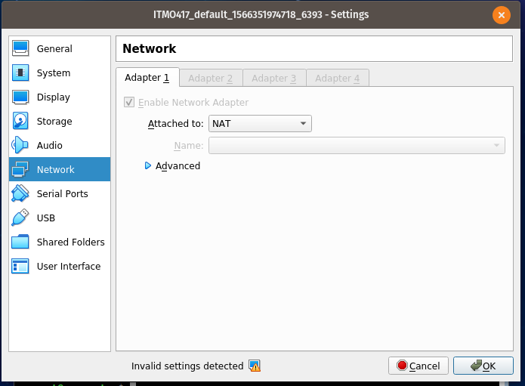

**Question 4**

There are two types of users; general users and super user. Explain how do you become a super user? Demonstrate how you become a super user. When you have successfully becoming a super user, exit from it and do a screen-shot on your work and submit the screen-shot as proof of your work.

If the username that you are logged in as is included in `/etc/sudoers` or as a file in the folder `/etc/sudoers.d/`, you can run the command `su` with no arguments to change your user to `root`.

In this case, I forgot my root password. I cannot run `su` because I need the root password to switch users to root. However, because I am a ‘sudoer’, I can run `sudo su` to start a new shell logged in as root.

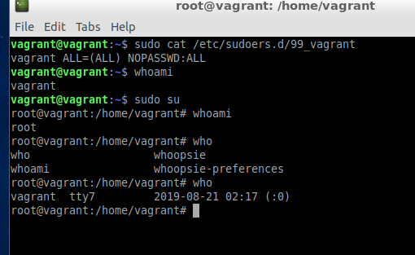

**Question 5**

Using Microsoft Word write a summary of what you have learned in this assignment (minimum of 150 words, use your own words). Summarize your report, do not use bullet items.

I already have a lot of familiarity with Linux and, if I am being honest, did not *learn* that many new things. However, I have gone over some things. I have gone over how to start a virtual machine and provision a Linux system from scratch. I have reviewed how to configure VirtualBox’s hardware settings such as RAM, CPU cores and throttle, and network.

I have actually learned one new thing: There is a folder called `/etc/sudoers.d/` that contains files which describe sudoers. Originally, I had assumed that only `/etc/sudoers` existed but this is a cool pattern I have seen recently: `*.d/` folders that contain multiple config files!

I have also set up this virtual machine using a command-line tool called Vagrant because it is a very fast and easy way to provision virtual machines, and can run commands upon starting up VMs. I have also made a new user with my username and will now use that username to log in:

